1. INTRODUCTION

  - Introduction to ICPT system

The term Contactless Power Transfer (CPT), in general, can be used to describe the power transfer between two objects that are physically unconnected. The word contactless‟ infers some sort of remote action, so that the transfer of power could occur over a physical distance i.e., anon-galvanic contact is established between the source and the load that enables power transfer”.In the context of electrical systems, CPT can be achieved by electromagnetic induction or electromagnetic radiation. In this thesis, CPT specifically refers to transfer of electric power between two or more galvanic ally isolated electric circuits by means of magnetic induction. However, in literature, there exist a large number of terms that describe the same phenomenon. Some of these terms are contactless inductive energy transfer (CIET), contactless energy transfer (CET), contactless inductive power transfer (CIPT), inductive power transfer (IPT), wireless power transfer (WPT), Witricity and so on.

The use of contactless power transfer is sometimes the only way of transferring power between the source and the load. CPT is must in applications where conventional cables and connectors are either impractical or useless – either for the sake of convenience, safety or because of the absence of another solution. Presently, there are a number of contactless power transfer solutions for applications with varying power levels and varying distances. The applications of this technology can range for power transfer to low power home and office devices to high power industrial applications. Medical, marine, space and transportation are some of the other areas in which this application is used.

1.2 State of the art of CPT technology

In this section, a brief outline of the state of research and production of CPT devices is Presented. Because of the large number of applications of CPT technology, this technology has the potential to make its way into the future technological agenda and might play a vital role in existent and future power transfer technologies. A wide spectrum of technological solutions using this technology has been researched and the scientific state of art is illustrated. The CPT solutions because of their large number of applications, for the sake of simplicity, are classified as low power and high power transfer.

Low power transfer

One of the perhaps most popular examples of commercially available low power device that use CPT system today are the range of Sonic are electrical toothbrushes by Philips. The toothbrushes are fitted with rechargeable batteries which can be charged by placing the toothbrush on a charging socket of the charger. In this application, the technology of CPT is employed to make the device electric shock proof. There are some companies that have come up with innovative solutions of powering or charging consumer electronic devices using CPT. These solutions include wireless charging of mobile electronics like cell phones, laptops etc., and direct wireless powering of stationary devices like TV‟s, desktop PCs, speakers, kitchen appliances, etc. A few of these companies are Witricity, Power mat Fujitsu etc. Use of CPT technology in very low power bio-medical applications has also been an area of interest for researchers. Direct wireless power interconnections and automatic wireless charging for implantable medical devices like ventricular assist devices, pacemakers, defibrillators etc. is being researched.
High power transfer

Contactless power transfer has also found a large number of applications where high power needs to be transferred wirelessly. The magnitude of power transfer can range from some kilowatts to hundreds of kilowatts. High power contactless power transfer has found Applications in people movers, industrial transport and automation, mining, military and aviation, electric vehicles etc. But, unlike low power transfer applications where the air gap between the load and source is very small and power transfer efficiency is comparatively small, in case of high power transfer the air gap are larger and efficiency of power transfer is intended to be high as the amount of power transfer is large. People movers that utilize the principle of magnetic levitation for their propulsion, along with propulsion, the train acquires by contactless means the energy needed to power its onboard circuits and to recharge the onboard batteries for backup power supply.

In case of industrial environments where the use of normal electrical cables and connectors is restricted, contactless transporters and contactless platforms can be used. In cases of underground works and exploration where the environment is more often than not highly explosive, conventional connectors are not safe. To tackle this problem sliding transformer has been proposed as a solution. Contactless power transfer technology is necessary in many military and space system where sealing of compartments is vital. A satellite rotary connection has been proposed for application in space application.

Contactless charging of electric vehicles (EV) is a widely researched topic in recent past as this technology can make electric vehicles a more user friendly. In this thesis, emphasis is given to the contactless charging of EVs and hence in the following section, CPT technology for charging of EVs is looked into in detail.

Fig. 1.1. Typical movable ICPT system.

  - Research goals and objectives

With the rising costs of fossil fuel, EVs will play a major role in future transportation and so it not the question of if but when. CPT technology has the potential to bring about a change in how EVs are perceived by making them more use- friendly and if not better, at par with conventional vehicles especially in the aspect of energy replenishment and cost.
The main goals of this thesis are to demonstrate CPT as a feasible technology for charging

Application in EV and to study the implications of such charging infrastructure on the driving range of an EV. To achieve these goals, following objectives were formulated:

• Develop firm theoretical background of a CPT system

The first objective of this thesis is to build firm theoretical background of the CPT
Technology based on the knowledge already existing in literature and to pin point key design Criteria of a CPT system. The theory so developed will not only be useful for designing a CPT system for EV applications but can be used in general for any CPT application.

• Demonstrate CPT by building a prototype

The second objective of this thesis is to build a demonstrator to demonstrate CPT using the theory developed already. The main objective of building a prototype is to demonstrate that efficient power transfer over relatively large air gaps is achievable. The secondary objective is to study certain practical aspects like tolerance to misalignment.

• Study the effect of CPT charging technology on the range of an EV

The third objective of this thesis is to study the effect of CPT infrastructure on the driving range of an EV. To achieve this, CPT infrastructure installed in urban and highway driving conditions will be considered. In urban scenario, CPT systems installed at traffic lights will be considered, for energy replenishment when the EV is idle at a stop light and in highway scenario, CPT system installed underneath the highway, for energy replenishment in motion, will be considered.

2. LITERATURE REVIEW

2.1 Introduction

INDUCTIVELY coupled power transfer (ICPT) system utilizes varying magnetic field at a certain frequency to couple power across an air gap to one or more secondary load systems without direct physical contact . ICPT system is safe, reliable, flexible, and environment friendly due to the electrical isolation of the system. It has many applications including portable electronic devices, electric vehicles, underwater power supply, automotive guided vehicles, and mining applications.

Rail transit system is one of the potential important applications of the ICPT system. Generally, the third rail or overhead line and pantograph are utilized to supply power for the vehicle. Insufferable defects of this supply method are friction, sparks, risk of electric shock, and high maintenance cost. The movable contactless power transfer (MCPT) system is an alternative proposal for the supply of rail transit system (see Fig. 1.1). The MCPT system contains the ground part and vehicle part; the primary windings are powered by converter located on the ground and the secondary windings pick up the power and then transfer it to vehicle load. Researchers presented a roadway powered vehicle with contactless power supply system.
An inductive power supply system for maglev was introduced. A tram in a city with contactless power supply system attached importance in Germany. For high-power application, it is necessary to regulate the output power of ICPT system with the load change. The early output power regulation method was to change the input dc voltage of inverter by the buck or boost converter. This method is simple, but it increases the power losses, size, and cost of the primary converter. A new series ac-processing pick up was utilized to eliminate the need of an extra buck converter for controlling the output load voltage, which was controlled on the secondary sides. A method of varying the phase-shifted angle of the full-bridge inverter was presented to regulate the fundamental of output voltage.

2.2 CPT system as present in literature

In literature review, an additional DC-DC converter is recommended in order to control the flow of charge to battery as shown in the Figure (a). However, an additional converter would also cause additional losses.

Hence, it is desirable to achieve load current control using the existing power electronics. A CPT system has been proposed in which the DC-DC converter has been eliminated and current control has been achieved by controlling the switching of the inverter (in the input side) and/or the active rectifier (in the output side). This proposed CPT system is shown in Figure (b). In this section, load current control for the proposed system is discussed. The load current control can be achieved from the load side and/or from the source side. The methodology of source side load current control is the same for the proposed scheme and the scheme existing in literature. However, in case of load side current control, current control by active rectifier is discussed.
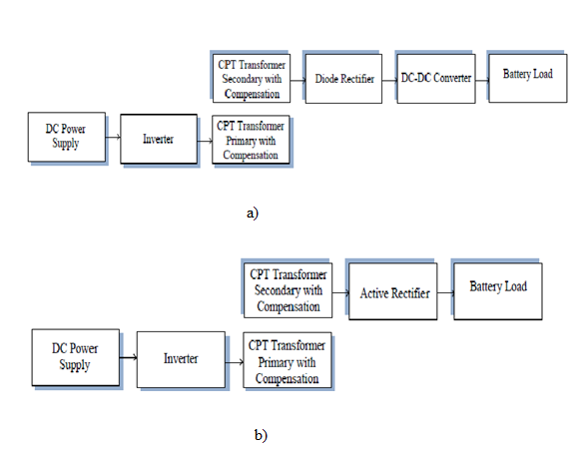

Figure 2.1. a) ICPT system as present in literature b) Proposed ICPT system

2.3 proposed ICPT system

We proposed an energy discontinuous injection and the free oscillation method. With this Method, the switching frequency is low with high frequency of output current, but the current waveforms have a small fluctuation. Four steady-states zero current switching (ZCS) operating points were adopted in, but the output voltage is not smooth. And compared to the four power conversion methods (voltage control, duty-cycle control, frequency control, and phase-shifted control) for the wireless charging system, and the phase-shifted control is considered to be the optimal scheme under the uniform load condition.

A typical circuit topology of an ICPT system for rail transit application is shown in Fig 2.2. It contains a set of primary winding coils near and along the rail, one or more secondary windings coil beneath the vehicle on board, primary converter, and secondary converters The primary converter transfers the three-phase 50 Hz ac source into dc voltage, then the inverter outputs high-frequency ac current to the primary winding coil and sets up high-frequency magnetic field. The high-frequency voltage is induced in the secondary winding coils which couple with the magnetic field. The secondary converter transforms the ac voltage to dc voltage for the load R_{L}, which represents inverter and motor.

To increase the transferred power, compensation capacitors are used in the secondary circuit usually. On the other hand, to decrease the apparent power of the primary converter, compensation capacitors are also used in the primary circuits. Typical topologies are series capacitor compensation, parallel capacitor compensation, and more complex resonant circuit. It is known that if both primary and secondary compensation capacitors are connected serially, the capacitance needed does not vary with load or with the mutual inductance between primary winding and secondary winding. So this project adopts this compensation topology.

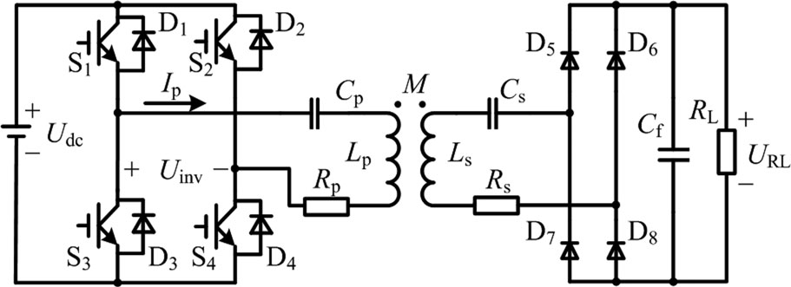

Fig. 2.2. Circuit topology of ICPT with series compensation.

As discussed before, the phase-shifted control for the full-bridge inverter is suitable to adjust the output power. In Fig. 3, the drive pulse duty width of each switching device is 50%, pulses of switch S4 and S2 lag that of S1 and S3 a certain phase angle α, the range of α is from 0◦ to 180◦
Where as
Lp Total inductance of the primary winding.
Ls Total inductance of the secondary winding.
M Mutual inductance.
Cp Resonant capacitor on the primary side.
Cs Resonant capacitor on the secondary side.
Rp Total resistance of the primary winding.
Rs Total resistance of the secondary winding.
RL Load resistance.
S1 − S4 Switching components.
D1 − D4 Freewheeling diodes.
D5 − D8 Diodes.
C_{f} Filter capacitor. U_{dc} Voltage of dc input sourc.
U_{inv} Inverter output voltage U_{RL} Voltage of load resistance

3. ANALYSIS AND DESIGN CONSIDERATIONS

3.1 Introduction

In this chapter the basic principles of contactless power transfer (CPT) by inductive coupling between the primary and secondary of a loosely coupled transformer is presented. Firstly, the basic concepts used to describe the power transfer between two inductively couples circuits is described. Secondly, the concept of compensation is introduced. Four different compensation techniques are discussed and it is described how compensation can be used to increase the power transfer capability and reduce the VA rating of a CPT system. The phenomenon of bifurcation is introduced for the compensated system and conditions have been presented for stable operation of a CPT system.

3.2 CPT transformer

An inductively coupled CPT system is capable of efficiently delivering power from a Stationary primary source to a movable or stationary secondary source over relatively large air gap. In an inductively coupled CPT system, power is magnetically transferred from the primary winding to the secondary winding of specially constructed transformer.
A number of transformer configurations have been proposed in literature. Generally, these transformers are composed of flat spiral windings. Some of these proposed transformer configurations have a magnetic core and others have an air core. Factors that influence the choice of transformer are air gap between the primary and secondary winding, cost of the magnetic material core, weight of the core, eddy current losses in the core, operating frequency and sensitivity to misalignment between primary and secondary windings. Figure 3.1 and Figure3.2 show the sectional view of transformer windings with magnetic core and air core respectively.

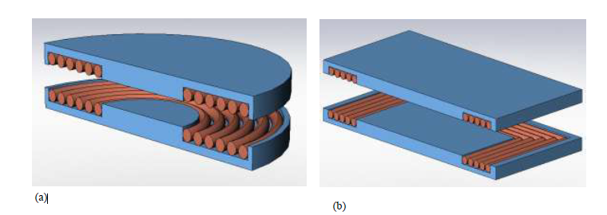Figure 3.1 CPT transformer windings with magnetic core a) circular geometry
b) rectangular geometry

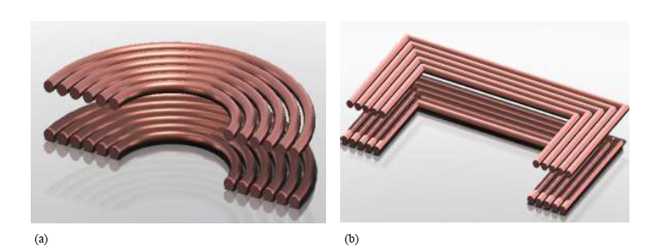
Figure 3.2 CPT transformer windings with air core a) circular geometry
b) rectangular geometry

The air gap in both the transformer configurations is large; so, both these configurations have a large leakage inductance and low mutual coupling which implies large magnetizing current. Since CPT transformer with air core is light in weight and has no core losses, for the analysis, CPT transformer with air core is considered. Also the CPT transformer with magnetic core, makes the circuit non-linear. Figure 3.3 shows the circuit representation of a CPT air core transformer. L1 and L2 represent the self inductance of primary and secondary winding respectively. The associated primary and secondary winding resistance is represented by R1 and R2 respectively. M is the mutual inductance between the transformer winding. The stray capacitances are neglected in representation of the CPT transformer as stray capacitance which dependent on the winding geometry and proximity of conductor to surfaces, become prominent at relatively high frequencies close to the self-resonance frequency of the transformer windings.

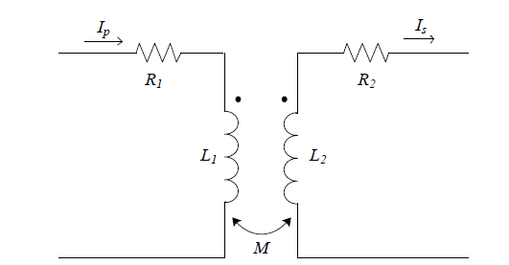

Figure 3.3 CPT air core transformer representation

Winding Resistance

The winding resistances R1 and R2 of CPT transformer are important factors that determine the efficiency and power transfer capability of a CPT transformer. The DC resistance calculations are based on the simple analytical expressions where the conductor resistivity, its cross-sectional area and length is used to calculate the resistance. At DC or very low frequencies, the magnetic fields inside the conductor are approximately static and hence no additional electric fields are induced in the conductor. The current density is such that it can be considered constant and uniform across the cross section of the conductor. The DC resistance is given by

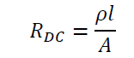
Where is the length of the conductor, A is the cross sectional area of the conductor and ℓ is the resistivity of the conductor material. Copper is the most preferable conductor for this application which has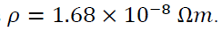
However, in CPT applications, the primary is excited with high frequency voltage source which in turn leads to high frequency currents in the windings of the CPT transformer. In general, a conductors carrying time varying current experiences magnetic fields due to their own currents and also magnetic fields due to all current carrying conductors in their vicinity which in turn induces eddy currents in the windings. These eddy currents oppose the penetration of the conductor by the magnetic fields and produce ohmic losses by converting electromagnetic energy into heat. There are two kinds of eddy current effects: the skin effect and the proximity effect. Both of these effects cause non uniform current density in conductors at high frequencies.

3.3 Basic CPT Transformer Analysis

In this section the basics of CPT are described. Figure 3.4 shows the circuit diagram for the inductive power transfer from a voltage source to a resistive load. It is assumed that the CPT Transformer has an air core and the frequency of operation is far below the self-resonance frequency and hence the stray capacitance can be neglected. The voltage source V₁ is a sinusoidal voltage source with an oscillation angular frequency of w. R_{L} represents the resistive load to which the power is to be transferred. The equivalent circuit representation of the CPT transformer is obtained and represented in Figure 3.5. This equivalent circuit representation makes the process of network analysis easier. In the equivalent representation L_{a}=L₂-M, and L_{b}= L₂-M, i.e., and represent the leakage inductances of primary and secondary windings respectively.

At high frequencies, however, Litz wire can be used to form the primary and secondary windings of the CPT transformer as these are designed specifically to minimize the skin effect and proximity effect. The Litz wire is constructed with number of thin insulated strands which are transposed or weaved in such a fashion that both the external proximity effect and the internal skin effect are reduced.

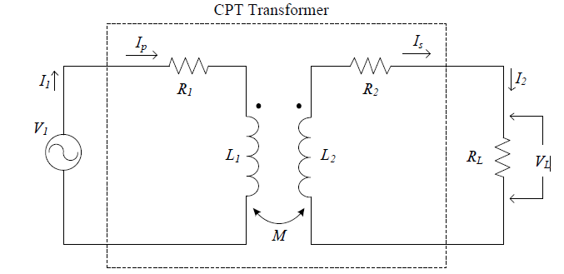

Figure 3.4 Schematic circuit of inductive power transfer to a resistive load

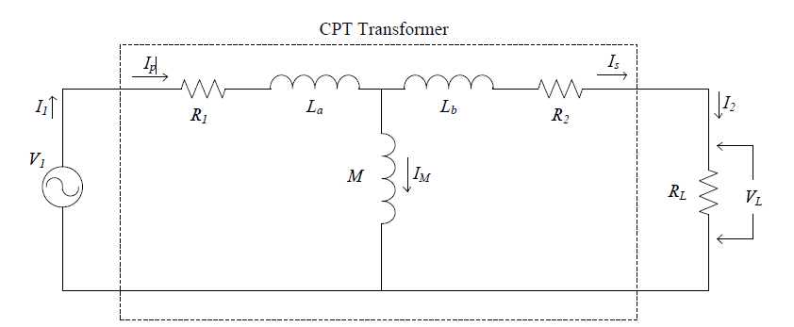

Figure 3.5 Schematic circuit of inductive power transfer to a resistive load with equivalent circuit representation of CPT transformer.

Network analysis of circuit shown in Figure 3.5 gives

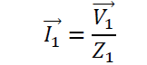
Where Z₁ is the impedance of the network as seen by the source given by

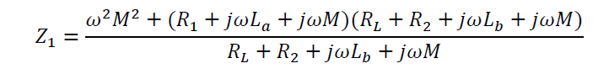

The efficiency of the power transfer is given by

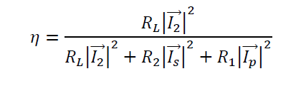
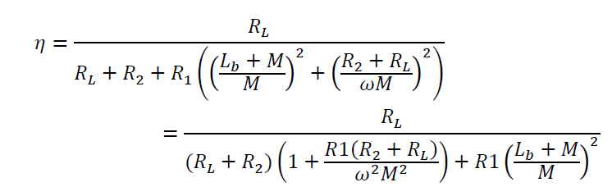

...(3.1)

But, for condition specified by Eqn.(3.2), power transfer at maximum possible efficiency occurs. This condition can be derived when 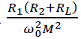tends to 0. The maximum theoretical

efficiency is given by Eq. (3.3).

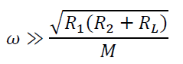 …(3.2)

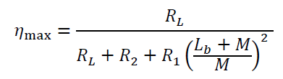 …(3.3)

This CPT transformer model is often used as first approximation to describe the operation Principle of contactless power transfer. The efficiency of the CPT transformer as indicated by Eq. (ii) depends on the load, primary and secondary winding of the CPT transformer. In order to attain high efficiency of CPT, the Eq. (2) must be satisfied which in turn means that the frequency of the source must be reasonably high.

The power factor, which is defined as the ratio of active power flowing into a device to the apparent power it draws, is highly dependent on the load and the CPT transformer inductances. However, in order to attain high efficiency of power transfer, high operational frequency satisfying Eq. (1) is desirable. But, at relatively high frequencies, the impedance as seen by the source becomes more and more inductive in nature. As a result, the power factor becomes very small and starts approaching zero as the frequency increases. This means that the high frequency source side inverter should have a large VA rating and the circulating power would also decrease the efficiency of power transfer. This is one of the major disadvantages of using basic CPT configuration for power transfer. To overcome this, capacitive compensation in both primary and secondary windings is recommended.

3.4 Capacitive Compensation

Compensation capacitors are used in CPT applications to increase the efficiency and the Capability of the system they are used in. Capacitive compensation is used in both the primary and secondary windings of the CPT transformer. The purpose of compensation in the secondary winding is to enhance the power transfer capability of the CPT transformer and the primary compensation is used to decrease the VA rating of the source side converter thereby ensuring power transfer at unity power factor. These capacitors essentially store and supply reactive power to and from the secondary and primary windings, reducing the amount of reactive power drawn from the supply.

There exist four basic types of compensation topologies. These are Series-Series (SS) compensation, Series-Parallel (SP) compensation, Parallel-Series (PS) compensation and Parallel-Parallel (PP) compensation.

To increase the power transfer capability of CPT system in all the above mentioned topologies, it is necessary that the system operates at the secondary resonance frequency. When operating at this frequency, the self inductance of the secondary winding is fully compensated by the secondary compensation capacitance and therefore the impedance of the secondary as seen by the primary is purely resistive in nature. Thus, for all the topologies, the value of compensation capacitance is C2 given by

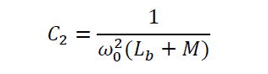

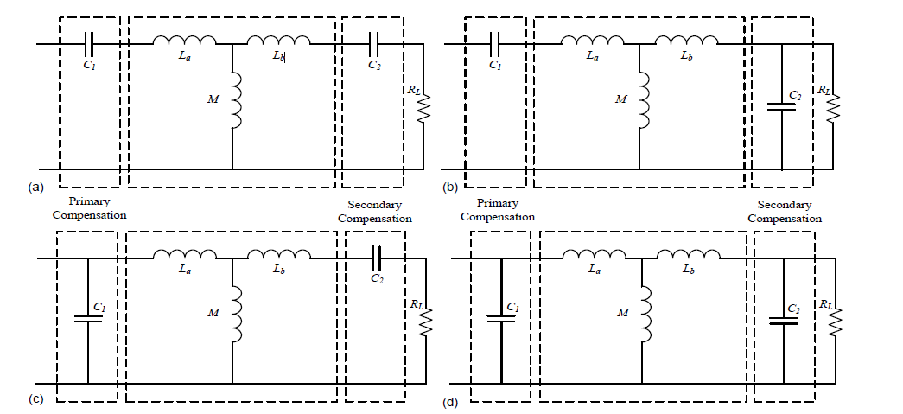

Figure 3.6 Compensation topologies (a) SS (b) SP (c) PS (d) PP

The primary compensation for all the compensation topologies is so chosen that the Impedance as seen from the source side is purely resistive in nature so as to ensure that high Frequency inverter which acts as the primary power source has minimum possible VA rating, i.e., the input current and voltage are in phase. Analysis of all four compensation topologies is presented in following sections and equations are derived for choice of primary compensation capacitance.

3.5 choice of Compensation topology

All the four topologies have different advantages and disadvantages, and their choice mainly depends on the type of application. Selecting a topology plays a vital role in the correct choice of primary capacitance as shown earlier. Since the series compensated secondary reflects no reactance at the nominal resonance frequency, the primary inductance can be tuned out independent of either the magnetic coupling or the load by series compensated primary network. As the parallel compensated secondary reflects a load-independent capacitive reactance at the nominal resonance frequency, series tuning in the primary is dependent on the magnetic coupling but not on the load. But, because the reflected impedance contain a real component representing the load, parallel tuning in the primary becomes dependent on both the magnetic coupling and the load.

However, for any general CPT system, SS topology has two major advantages that make it exceptionally useful. Firstly, the reflected impedance of the secondary winding on to the primary winding has only a real reflected component and no reactive component. This means that the secondary winding will draw only active when operating at secondary resonance frequency, giving the secondary a unity power factor. The second advantage is that the choice of primary and secondary compensation capacitances is independent of either mutual inductance or the load which means that the primary and secondary resonance frequencies are independent of either the mutual inductance or the load and only depend on the self inductance of the primary and secondary windings and their respective compensation capacitances. Therefore, for applications where relative orientations of the windings as well as load currents are variable, it is desirable to have a CPT system which has a resonant frequency independent of these variables.

In many CPT applications, the transferred power is used to replenish battery charge which means that in these applications, the load is a battery which needs to be recharged. Some of these applications are EV battery charging, battery charging of consumer electronics like cell phones etc. For battery charging applications, SS topology provides some very specific advantages which are described in the following section.

3.5.1 SS compensation topology

Li-ion batteries, because of their high specific power and ability to charge quickly, are being extensively used in applications where batteries act as the primary energy source. The charging process of a Li-ion battery can be divided into two stages; the constant current charging stage and the constant voltage charging stage. During the constant current charging stage, the battery is charged at constant current until the specified peak voltage of battery cells is reached. There is a linear rise of the battery cell voltage during this period of constant current charging. During the constant voltage charging stage, the charging takes place at constant voltage. At the end of constant current charging stage, the battery cell voltage is at the specified peak value and this voltage is maintained across the battery cell throughout the constant voltage charging stage. Therefore, a topology that acts as both a constant current
source and constant voltage is very much desirable in battery charging application. Based on the frequency of operation, a SS topology CPT system can act as a constant current source and a constant voltage source without any complex sensory control involved.

In SS topology, the primary compensation capacitance is only dependent on the secondary resonance frequency and the self- inductance of the primary winding. The self inductance of both the primary and secondary windings is independent the relative position of the two windings and only depend on the physical dimensions and geometry of the windings.

However, the objective is also to attain high efficiencies of power transfer through CPT. Therefore the behavior of CPT efficiency with respect to the operating frequency of the power source is studied.

The other losses associated with the converter are the conduction losses which are dependent on the type of switches used. In case of MOSFETs as the switching component, the conductions losses are dependent on the current flowing through the switch and the on state drain to source resistance. So, for a given current, to reduce the conduction losses, MOSFET with larger current rating can be used as these have lower Using MOSFETs with large current rating will, however, mean that larger gate current is required to turn on the MOSFET which may cause greater constraints on the driver circuit employed.

In case of IGBT as the switching device, the conduction losses are smaller when compared to that of MOSFET owing to the low forward voltage characteristics. But IGBTs are not as fast as MOSFETs and the choice between the two should be made based on the switching frequency and power rating of the converter.
However, diodes can have more complicated behavior than this simple on–off action. Semiconductor diodes do not begin conducting electricity until a certain threshold voltage is present in the forward direction (a state in which the diode is said to be forward biased). The voltage drop across a forward biased diode varies only a little with the current, and is a function of temperature; this effect can be used as a temperature sensor or voltage reference.
Semiconductor diodes have nonlinear electrical characteristics, which can be tailored by varying the construction of their P–N junction. These are exploited in special purpose diodes that perform many different functions.
Diodes were the first semiconductor electronic devices. The discovery of crystals' rectifying abilities was made by German physicist Ferdinand Braun in 1874. The first semiconductor diodes, called cat's whisker diodes, developed around 1906, were made of mineral crystals such as galena. Today most diodes are made of silicon, but other semiconductors such as germanium are sometimes used.
The most common function of a diode is to allow an electric current to pass in one direction (called the diode's forward direction), while blocking current in the opposite direction (the reverse direction). Thus, the diode can be thought of as an electronic version of a check valve. This unidirectional behavior is called rectification, and is used to convert alternating current to direct current, and to extract modulation from radio signals in radio receivers.

4. POWER ELECTRONICS REQUIREMENTS
4.1 Introduction
Power Electronics is a field which combines Power (electric power), Electronics and Control systems. Power engineering deals with the static and rotating power equipment for the generation, transmission and distribution of electric power. Electronics deals with the study of solid state semiconductor power devices and circuits for Power conversion to meet the desired control objectives (to control the output voltage and output power).
Power electronics may be defined as the subject of applications of solid state power semiconductor devices (Thyristors) for the control and conversion of electric power.
Power electronics deals with the study and design of Thyristorised power controllers for variety of application like Heat control, Light/Illumination control, Motor control – AC/DC motor drives used in industries, High voltage power supplies, Vehicle propulsion systems, High voltage direct current (HVDC) transmission.

4.2 Power Electronics Applications
- COMMERCIAL APPLICATIONS
Heating Systems Ventilating, Air Conditioners, Central Refrigeration, Lighting, Computers and Office equipments, Uninterruptible Power Supplies (UPS), Elevators, and Emergency Lamps.

- DOMESTIC APPLICATIONS
Cooking Equipments, Lighting, Heating, Air Conditioners, Refrigerators & Freezers, Personal Computers, Entertainment Equipments, UPS.

- INDUSTRIAL APPLICATIONS
Pumps, compressors, blowers and fans. Machine tools, arc furnaces, induction furnaces, lighting control circuits, industrial lasers, induction heating, welding equipments.

- AEROSPACE APPLICATIONS
Space shuttle power supply systems, satellite power systems, aircraft power systems.

- TELE COMMUNICATIONS
Battery chargers, power supplies (DC and UPS), mobile cell phone battery chargers.
- TRANSPORTATION
Traction control of electric vehicles, battery chargers for electric vehicles, electric locomotives, street cars, trolley buses, automobile electronics including engine controls.
- UTILITY SYSTEMS
High voltage DC transmission (HVDC), static VAR compensation (SVC), Alternative energy sources (wind, photovoltaic), fuel cells, energy storage systems, induced draft fans and boiler feed water pumps.

4.3 Differences between electronics and power electronics
This question can be answered in number of ways. The simplest way to say all the electronics devices which deals with power are covered in Power Electronics. There are devices which you do use in general purpose electronics like: Diode, BJT, MFETs etc. You will find these devices in electronics & power electronics both. The devices used in Power electronics may differ in term of construction & behavior from those used in electronics. There are type of devices which you will find only IN PE, ex: IGBT.
- The only difference is that power devices (e.g. MOSFETs) are made to handle much larger power requirements.
- Ordinary devices are low current and low voltage devices.
- Power devices are high current and/or high voltage devices.
4.4 Power converters
A power converter is an electrical or electro-mechanical device for converting electrical energy. It may be converting AC to or from DC, or the voltage or frequency, or some combination of these.
Amongst the many devices that are used for this purpose are;
- Rectifier
- Inverter
- DC - DC converter
- AC - AC converter

AC - DC Converter (Rectifier):
A rectifier is an electrical device that converts alternating current (AC), which periodically reverses direction, to direct current (DC), which is in only one direction, a process known as rectification.
Rectifiers have many uses including as components of power supplies and as detectors of radio signals. Rectifiers may be made of solid state diodes, vacuum tube diodes, mercury arc valves, and other components.
DC - AC Converter (Inverter)
An inverter is an electrical device that converts direct current (DC) to alternating current (AC); the converted AC can be at any required voltage and frequency with the use of appropriate transformers, switching, and control circuits.
Solid-state inverters have no moving parts and are used in a wide range of applications, from small switching power supplies in computers, to large electric utility high-voltage direct current applications that transport bulk power. Inverters are commonly used to supply AC power from DC sources such as solar panels or batteries.
DC - DC Converter (Choppers)
A dc chopper is a dc-to-dc voltage converter. It is a static switching electrical appliance that in one Electrical conversion, changes an input fixed dc voltage to an adjustable dc output voltage without Inductive or capacitive intermediate energy storage. The name chopper is connected with the fact that the output voltage is a ‘chopped up’ quasi-rectangular version of the input dc voltage.
AC - AC Converter
An AC/AC converter converts an AC waveform such as the mains supply, to another AC waveform, where the output voltage and frequency can be set arbitrarily.
AC/AC converters can be categorized into
- Cycloconverters
- Matrix Converters

4.5 Power Electronic Switches:
In electronics, a switch is an electrical component that can break an electrical circuit, interrupting the current or diverting it from one conductor to another.
A power electronic switch integrates a combination of power electronic components or power semiconductors and a driver for the actively switchable power semiconductors. The internal functional correlations and interactions of this integrated system determine several
Diodes
In electronics, a diode is a type of two-terminal electronic component with a nonlinear current–voltage characteristic. A semiconductor diode, the most common type today, is a crystalline piece of semiconductor material connected to two electrical terminals. A vacuum tube diode (now rarely used except in some high-power technologies) is a vacuum tube with two electrodes: a plate and a cathode.
The most common function of a diode is to allow an electric current to pass in one direction (called the diode's forward direction), while blocking current in the opposite direction (the reverse direction). Thus, the diode can be thought of as an electronic version of a check valve. This unidirectional behavior is called rectification, and is used to convert alternating current to direct current, and to extract modulation from radio signals in radio receivers.
However, diodes can have more complicated behavior than this simple on–off action. Semiconductor diodes do not begin conducting electricity until a certain threshold voltage is present in the forward direction (a state in which the diode is said to be forward biased). The voltage drop across a forward biased diode varies only a little with the current, and is a function of temperature; this effect can be used as a temperature sensor or voltage reference.
Semiconductor diodes have nonlinear electrical characteristics, which can be tailored by varying the construction of their P–N junction. These are exploited in special purpose diodes that perform many different functions.
Diodes were the first semiconductor electronic devices. The discovery of crystals' rectifying abilities was made by German physicist Ferdinand Braun in 1874. The first semiconductor diodes, called cat's whisker diodes, developed around 1906, were made of mineral crystals such as galena. Today most diodes are made of silicon, but other semiconductors such as germanium are sometimes used.
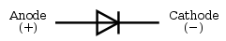
Fig 4.1 : Diode
A modern semiconductor diode is made of a crystal of semiconductor like silicon that has impurities added to it to create a region on one side that contains negative charge carriers (electrons), called n-type semiconductor, and a region on the other side that contains positive charge carriers (holes), called p-type semiconductor. The diode's terminals are attached to each of these regions. The boundary within the crystal between these two regions, called a PN junction, is where the action of the diode takes place. The crystal conducts a current of electrons in a direction from the N-type side (called the cathode) to the P-type side (called the anode), but not in the opposite direction. However, conventional current flows from anode to cathode in the direction of the arrow (opposite to the electron flow, since electrons have negative charge).
Another type of semiconductor diode, the Scotty diode, is formed from the contact between a metal and a semiconductor rather than by a p–n junction.
Thyristors
A thyristor is a solid-state semiconductor device with four layers of alternating n and p-type material. They act as bistable switches, conducting when their gate receives a current pulse, and continue to conduct while they are forward biased (that is, while the voltage across the device is not reversed).
Some sources define silicon controlled rectifiers and thyristors as synonymous.
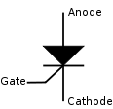
Fig 4.2: Circuit symbol for a Thyristor

Function
The thyristor is a four-layer, three terminal semiconducting device, with each layer consisting of alternately N-type or P-type material, for example P-N-P-N. The main terminals, labeled anode and cathode, are across the full four layers, and the control terminal, called the gate, is attached to p-type material near to the cathode. (A variant called an SCS—Silicon Controlled Switch—brings all four layers out to terminals.) The operation of a thyristor can be understood in terms of a pair of tightly coupled bipolar junction transistors, arranged to cause the self-latching action:
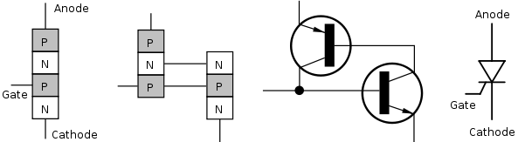Fig 4.3 : Structure on the physical and electronic level, and the thyristor symbol.
Thyristors have three states:
- Reverse blocking mode — Voltage is applied in the direction that would be blocked by a diode
- Forward blocking mode — Voltage is applied in the direction that would cause a diode to conduct, but the thyristor has not yet been triggered into conduction
- Forward conducting mode — The thyristor has been triggered into conduction and will remain conducting until the forward current drops below a threshold value known as the "holding current"

Insulated Gate Bipolar Transistor (IGBT):
The insulated-gate bipolar transistor or IGBT is a three-terminal power semiconductor device, noted for high efficiency and fast switching. It switches electric power in many modern appliances: electric cars, variable speed refrigerators, air-conditioners, and even stereo systems with digital amplifiers. Since it is designed to rapidly turn on and off, amplifiers that use it often synthesize complex waveforms with pulse width modulation and low-pass filters.
The IGBT combines the simple gate-drive characteristics of the MOSFETs with the high-current and low–saturation-voltage capability of bipolar transistors by combining an isolated-gate FET for the control input, and a bipolar power transistor as a switch, in a single device. The IGBT is used in medium- to high-power applications such as switched-mode power supply, traction motor control and induction heating. Large IGBT modules typically consist of many devices in parallel and can have very high current handling capabilities in the order of hundreds of amps with blocking voltages of 6,000 V.
Equivalent Circuit:
An examination of reveals that if we move vertically up from collector to emitter. We come across p+, n- , p layer s. Thus, IGBT can be thought of as the combination of MOSFET and p+ n⁻ p layer s. Thus, IGBT can be thought of as the combination of MOSFET and p⁺ n⁻ p transistor Q1 .Here Rd is resistance offered by n – drift region. Approximate equivalent circuit of an IGBT.
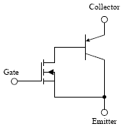
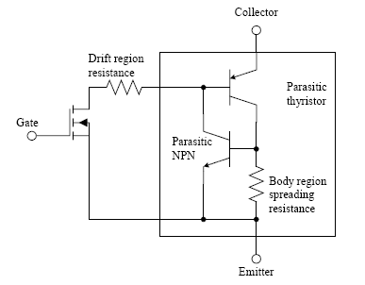
Fig 4.4:Equivalent circuit MOSFET
The metal–oxide–semiconductor field-effect transistor (MOSFET, MOS-FET, or MOS FET) is a transistor used for amplifying or switching electronic signals. The basic principle of this kind of transistor was first proposed by Julius Edgar Lilienfeld in 1925. In MOSFETs, a voltage on the oxide-insulated gate electrode can induce a conducting channel between the two other contacts called source and drain. The channel can be of n-type or p-type (see article on semiconductor devices), and is accordingly called an nMOSFET or a pMOSFET (also commonly nMOS, pMOS). It is by far the most common transistor in both digital and analog circuits, though the bipolar junction transistor was at one time much more common.
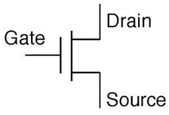
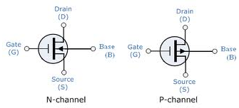

The 'metal' in the name is now often a misnomer because the previously metal gate material is now often a layer of polysilicon (polycrystalline silicon). Aluminium had been the gate material until the mid 1970s, when polysilicon became dominant, due to its capability to form self-aligned gates. Metallic gates are regaining popularity, since it is difficult to increase the speed of operation of transistors without metal gates.
MOSFET Operation:
A metal–oxide–semiconductor field-effect transistor (MOSFET) is based on the modulation of charge concentration by a MOS capacitance between a body electrode and a gate electrode located above the body and insulated from all other device regions by a gate dielectric layer which in the case of a MOSFET is an oxide, such as silicon dioxide. If dielectrics other than an oxide such as silicon dioxide (often referred to as oxide) are employed the device may be referred to as a metal–insulator–semiconductor FET (MISFET). Compared to the MOS capacitor, the MOSFET includes two additional terminals (source and drain), each connected to individual highly doped regions that are separated by the body region. These regions can be either p or n type, but they must both be of the same type, and of opposite type to the body region. The source and drain (unlike the body) are highly doped as signified by a '+' sign after the type of doping.
If the MOSFET is an n-channel or nMOS FET, then the source and drain are 'n+' regions and the body is a 'p' region. As described above, with sufficient gate voltage, holes from the body are driven away from the gate, forming an inversion layer or n-channel at the interface between the p region and the oxide. This conducting channel extends between the source and the drain, and current is conducted through it when a voltage is applied between source and drain. Increasing the voltage on the gate leads to a higher electron density in the inversion layer and therefore increases the current flow between the source and drain.
For gate voltages below the threshold value, the channel is lightly populated, and only a very small sub threshold leakage current can flow between the source and the drain.
If the MOSFET is a p-channel or pMOS FET, then the source and drain are 'p+' regions and the body is a 'n' region. When a negative gate-source voltage (positive source-gate) is applied, it creates a p-channel at the surface of the n region, analogous to the n-channel case, but with opposite polarities of charges and voltages.
When a voltage less negative than the threshold value (a negative voltage for p-channel) is applied between gate and source, the channel disappears and only a very small sub threshold current can flow between the source and the drain.

5. RESONANT CONVERTER TOPOLOGY

5.1 Introduction

There are various kinds of soft switching techniques that can be employed to achieve higher power densities, higher efficiencies and smaller sizes of converters. Soft switching techniques in general enable high frequency switching at high efficiencies by reducing the switching losses and thereby reducing the overall size of the converter by reducing the sizes of the passive components and heat sinks. In a CPT system, it would be a natural choice to go for resonant converter topology switching at resonance frequency of the designed CPT system. This is because, in order to increase the power transfer capability of the CPT transformer and to reduce the VA rating of the converter, the primary and secondary windings are compensated with capacitors. The primary compensation which ensures that the input current and voltage are in phase also indirectly ensures that when switching at resonance frequency, the switching action of the switches would take place at the instance when the current flowing through the switches is zero. This means that Zero Current Switching (ZCS) can be accomplished at resonance frequency switching. In this chapter, to start with, resonant converter topology for CPT system is introduced. Losses in power electronic components in various stages of a CPT system are discussed. Finally, methods of load current control for SS compensation based topology is discussed

5.2 Resonant converter topology for ICPT system

A resonant power converter contains resonant circuits whose voltage and current waveforms vary sinusoidal during one or more subintervals of switching periods. For the application of ICPT systems, the converters have low harmonic distortion because switching takes place at resonant frequency.

It is convinced of that both the primary and the secondary converters operate at resonance if (5.1) and (5.2) are satisfied. The impedances Zpk and Zsk become purely resistive, and the maximum power transfer capability is achieved. The Pok is the nthe function of the following two independent variables: ωs and α. The former is determined by the switching frequency and the latter is the pulse phase-shifted angle of inverter

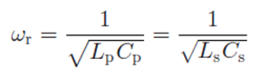 ….(5.1)

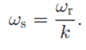 ….(5.2)

Fig 5.1 Harmonic model equivalent circuit of ICPT with series compensation.

In the conventional method, the power is transferred by fundamental component, and harmonic components are usually neglected. So, the conventional phase-shifted control is called fundamental-based phase-shifted control (FPSC) in this paper. To analyze the harmonic components, fast Fourier transform (FFT) of the inverter output voltage is carried out at first. Here, the dead time of inverter is not considered, the root-mean-square (RMS) value of the k^{th}-order harmonic component of inverter output voltage is given by

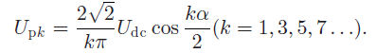

The fundamental model equivalent circuit of ICPT system is presented. Similarly, the kth-order harmonic model is built in this paper to analyze the effect of the harmonic components as well as the fundamental to the transferred power. The harmonic model equivalent circuit with series capacitors on both sides is shown in Fig. 4.1 As indicated in Fig. 4.1, the primary current Ipk and secondary current Isk can be expressed as

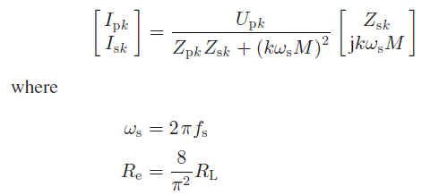
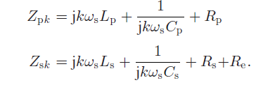
In the conventional FPSC, the switching frequency is equal to the resonant frequency, and the output power is regulated by changing α. However, the switching losses increase as α approaching to 180◦, which results in poor efficiency at the light-load condition. If harmonic components are utilized, the switching losses may decrease due to the low switching frequency. From analyses aforementioned, the condition to transfer power by harmonic is (5.2). In other words, the selected should equal to resonant frequency by decreasing the switching frequency.

Converter efficiency

In a SS compensated resonant converter shown in Figure 4., losses in the inverter stage, CPT transformer and diode rectifier amount for the majority of losses. Losses in the CPT transformer arise due to resistance associated with the CPT transformer windings which become quite dominating at high operational frequency as discussed in chapter 2. Losses in the input side inverter and load side rectifier are looked more closely in this section.

The other losses associated with the converter are the conduction losses which are Dependent on the type of switches used. In case of MOSFETs as the switching component, the conductions losses are dependent on the current flowing through the switch and the on state drain to source resistance So, for a given current, to reduce the conduction losses, MOSFET with larger current rating can be used as these have lower Using MOSFETs with large current rating will, however, mean that larger gate current is required to turn on the MOSFET which may cause greater constraints on the driver circuit employed. In case of IGBT as the switching device, the conduction losses are smaller when compared to that of MOSFET owing to the low forward voltage characteristics. But IGBTs are not as fast as MOSFETs and the choice between the two should be made based on the switching frequency and power rating of the converter.

Rectifier efficiency

Rectification of AC power to DC could very easily be achieved using a diode bridge rectifier. However, efficiency wise, this is not a very good option. Not much emphasis has been given in literature to the power loss in the rectification stage. In most of the references that analyze and discuss the CPT for battery charging application this aspect is neglected. Diode rectifiers lead to large losses and can significantly reduce the efficiency of the system.

Diodes that are employed in low switching frequency converters have predominantly
conduction losses. However, at high switching frequency, the transient losses in a diode are also quite significant. The conduction losses in a diode are due to forward bias voltage and the on state resistance. The transient losses in a diode are due to the phenomenon of reverse recovery current. So for large conduction currents and high frequency rectification, the losses in the diodes can become significantly high. Schottky diodes can be employed for high frequency operation as they have a very low reverse recovery current but then their forward bias voltage drop is quite significant and thereby increases the conduction losses. Therefore, in applications of CPT battery charging which requires high output currents and also relatively high switching frequency operations, diode rectification is not a very efficient option. In order to achieve high efficiency rectification, active rectifiers must be employed. This would also mean that additional controls have to be used to control the switching in the active rectifier which is a drawback both in terms reliability and cost of the system. But, the active rectifier also presents the opportunity to control the load current.

Load current control from source side

Source side current control can be achieved by controlling the switching of switches S1, S2, S3 and S4 shown in Figure 3.1 One way of doing this is by keeping the switching frequency constant at the resonance frequency and change the turn on and turn off duration of the switches, the other way is by changing the switching frequency itself. Later is however not a good way of achieving current control because at off resonance frequency the system efficiency goes down drastically. So, in order to achieve current control at resonance frequency, a switching scheme is proposed namely “α-control ”.

α-control

In α -control, the switching durations and instances of switches S1, S2, S3 and S4 are controlled in such a way that that fundamental component of the voltage u₁(t)i.e., u₁₍₁₎(t) has a frequency equal to the designed resonance frequency of the CPT transformer. The control of the load current is achieved by varying the amplitude of as governed. This control is named as α -control because during one full cycle, for a duration corresponding to, the current flows once thorough the anti-parallel diodes D1 and D4, and once through the anti-parallel diodes D2 and D3. Figure 5.2. Shows the gate signal to all the switches.

fig 5.2 Key waveforms of HPSC with third-order harmonic
For α=0, turn-on and turn-off of switches S1, S2, S3 and S4 occur at instance when the current through the corresponding switches is zero, i.e., ZCS occurs. This results in lower switching losses and thereby makes the power transfer more efficient. For any other , the turn-on of switches S1 and S3 and turn-off of switches S2 and S4 occur at instances of zero current i.e., ZCS occurs. The proposed CPT system of the experimental setup is simulated in MATLAB Simulink. With -control being incorporated in the simulated system, the theoretical and simulation results for the load current control correlate closely as shown in last chapter.

However, one disadvantage of this current control method is that during the duration when neither of the switch pair is conducting, the current flows through the anti-parallel diodes D1 and D4 or D2 and D3 which is generally undesirable because of larger conduction losses that are encountered when current flows through the anti-parallel diodes. Moreover, since these diodes are parasitic, the characteristics of these are dependent on the characteristics of the switch that is being used and cannot be altered. So, in order to reduce the conduction losses during these durations, the parasitic diode can be bypassed by diode of better conduction characteristics but this will also involve another diode which has to be connected in series to the switch causing additional losses.

Diodes that are employed in low switching frequency converters have predominantly conduction losses. However, at high switching frequency, the transient losses in a diode are also quite significant. The conduction losses in a diode are due to forward bias voltage and the on state resistance. The transient losses in a diode are due to the phenomenon of reverse recovery current. So for large conduction currents and high frequency rectification, the losses in the diodes can become significantly high.

6. THE HARMONIC-BASED PHASE-SHIFTED CONTROL

Introduction

As analyzed in the previous section , the harmonic components of inverter output voltage can be used to transfer power by changing switching frequency. Besides, to regulate output power accurately, phase-shifted control is used. Detailed analysis of HPSC is as follow. At first, harmonic components of inverter output voltage must be found out. To show it generally, normalized value is introduced. Based on the RMS value of fundamental component of the inverter output voltage Up1 at zero phase-shifted angle, the normalized value of the kth-order harmonic RMS value at phase-shifted angle α is expressed as

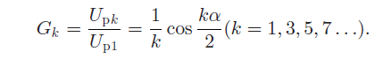 …..(6.1)

Fig. 6.1 Normalized value of fundamental and harmonic components at different phase-shifted angle.

Fig. 6.1 shows the normalized value of fundamental and harmonic components at different phase-shifted angle α, where 1stmeans the fundamental component, 3rd, 5th, 7th, and 9th mean the high-order harmonic component, respectively.

In Fig. 6.1, fundamental component gets smaller with phase shifted angle approaching to 180◦. The maximum value of normalized value of the k^{th}-order harmonic Gk is 1/k according to (6.1). Once G1 becomes less than 1/k, the k^{th}-order harmonic component instead of fundamental component can be used to transfer the same capacity of power. The switching frequency could be decreased to 1/k times of the resonant frequency. The output power can be regulated by the changing phase-shifted angle.

To illustrate this method, Fig. 5.2. shows key waveforms of the third-order harmonic-based phase-shifted control method. Furthermore, a half switching period in Fig.5.2 is subdivided into six stages and their simplified paths in different stages are shown in Fig. 6.
Stage 1 [t0, t1 ]: S3 turns OFF at t0. Fromt0 to t1 , the poweris oscillating freely through S2, Lp, Zr, Rp, Cp , and D1 . Uinv is equal to 0 during this stage.

Stage 2 [t1, t2 ]: At t1, S1 turns ON at zero voltage switching (ZVS) when D1 conducts. The power is oscillating freely through S1, Cp,Rp, Zr, Lp , and D2 .

Stage 3 [t2, t3 ]: At t2, S2 turns OFF at ZVS when D2 conducts.

Stage 4 [t3, t4 ]: S4 turns ON at t3 , and D2 turns OFF at the same time. The conduction current through S4 is same with the turning OFF current of D2 . The power is transferred from input dc source to load through S1, Cp,Rp, Zr, Lp , and S4 . Uinv is equal to Udc during this stage.

Stage 5 [t4, t5 ]: Inverter output current Ip crosses zero and changes its direction at t4 . The power is circulated from load to input dc source through D4, Lp, Zr,Rp, Cp , and D1 . This stage finishes when Ip reaches zero.
Stage 6 [t5, t6 ]: After the current Ip crosses zero and changes its direction at t5 , the power is transferred from input dc source to load through S1, Cp,Rp, Zr, Lp , and S4 during this stage. This stage ends when S1 turns OFF at t6 .

Fig 6.2 Simplified Paths Of HPSC With Third-Order Harmonic In Half Switching Period.

The stages of the other half period are similar with that of above. The current Ip circulates three times during one switching period, which means lower switching losses compared with FPSC.

For higher order harmonic-based phase-shifted control, there will be more current circulation during one switching period and lower switching losses.

An inverter is an electrical device that converts direct current (DC) to alternating current (AC); the converted AC can be at any required voltage and frequency with the use of appropriate transformers, switching, and control circuits.
Solid-state inverters have no moving parts and are used in a wide range of applications, from small switching power supplies in computers, to large electric utility high-voltage direct current applications that transport bulk power. Inverters are commonly used to supply AC power from DC sources such as solar panels or batteries.

Table.1. SWITCHING PHASE-SHIFTED ANGLES FOR FUNDAMENTAL AND HARMONICS

A rectifier is an electrical device that converts alternating current (AC), which periodically reverses direction, to direct current (DC), which is in only one direction, a process known as rectification.
Rectifiers have many uses including as components of power supplies and as detectors of radio signals. Rectifiers may be made of solid state diodes, vacuum tube diodes, mercury arc valves, and other components

Table.2. Normalized Output Power And Phase-Shifted Angle Range.

So, the reasonable normalized output power range of the kth order harmonic is from 1/(k + 2)² to 1/k². Table 2. shows there as on able normalized output power range in percentage and phase-shifted angle range for fundamental and harmonic components. The normalized output power range of HPSC is less than 1/3² or 11.1% theoretically, and the phase-shifted range for harmonic component is much wider than that for fundamental.

In fact, the range of normalized output power is a little higher since the maximum output power decreased due to the dead time of an inverter.

7. SWITCHING STRATEGY FOR HARMONIC COMPONENTS

7.1 Introduction

From Fig. 6.1, it is evident that several harmonic components meet the demand of low output power. The switching strategy for different order harmonic is discussed as follows.

First, α_{1k} is defined as the switching phase-shifted angle from fundamental to the kth-order harmonic component. When fundamental component is at resonance, the kth-order harmonic component could be employed to transfer the same power if the phase-shifted angle is greater than α_{1k}. The maximum value of G_{k} is 1/k, so from the relationship G₁ = 1/k, α_{1k}can be expressed as

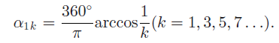 ……(7.1)

Similarly, α_{k} is defined as switching phase-shifted angle from the kth-order harmonic to (k + 2) th-order harmonic. When the k-th-order harmonic is at resonance, if the phase-shifted angle is greater than α_{k}, then (k +2) th-order harmonic can be used to transfer same capacity of power. It means the reasonable phase shifted angle range of the kth-order harmonic can be 0 to α_{k}. From the relationship G_{k}= 1/(k+2), α_{k} can be expressed as

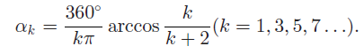 …….(7.2)

The switching phase-shifted angles for fundamental and harmonic components are shown in Table 1. According to P_{ok} and G_{k} expressions, ignore the components which are not at resonance, the normalized value of output power is

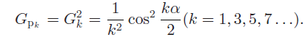 …….(7.3)

To vividly describe the contribution of the harmonic components to transferred power, output power is plotted according to P_{ok} .in Fig. 7. In this figure, (a), (b), and (c) correspond to the switching frequencies 42, 14, and 8.4 kHz, respectively, under the condition of pulse phase-shifted angle α being zero. Other parameters are shown in Table I. It indicates in the Fig. 4 that if the switching frequency is selected as eqn.(y) the output power is

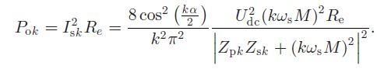 …..(7.4)

It indicates in the Fig. 7 that if the switching frequency is selected as per eqn. (y) the output power is mainly transferred by the harmonic component at the resonant frequency. What is more, the transferred power by the third order harmonic and fifth-order harmonic component is nearly1/9 and 1/25 times that of the fundamental component.

Whenever there is a misalignment between the primary and secondary windings, the mutual inductance between the windings of the CPT transformer would reduce. Because of this reduction in the mutual inductance, the reflected impedance of the secondary on to the primary will also reduce which in turn will lead to higher primary current causing higher resistive losses in the primary winding and hence the reduction in power transfer efficiency is observed.

Fig. 7.1 Output power with different harmonic components under fr = 42 kHz:
(a) fs = 42 kHz, (b) fs = 14 kHz, and (c) fs = 8.4 kHz.

7.2 Effect of the dead time

The dead time is necessary to avoid current passing directly through any bridge arm of an inverter. Because it will bring some effect to duty width, it must be considered especially for high frequency switching. For example, the effective duty width will be decreased from 50% to 41.6% if dead time is 2 μs and switching frequency is 42 kHz, which results in decreased maximum output power. Here, α_{kd}is defined as equivalent phase-shifted
angle of dead time for the k^{th} order harmonic in HPSC, and it is expressed as
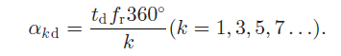

Considering the dead time effect, the equations with phase shifted angle α will be updated. Taking Upk as an example, (1)is updated as

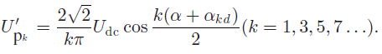

Besides, the switching phase-shifted angle will be updated as

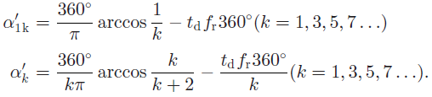

It is evident that the phase-shifted angle for the maximum value of Upk (k = 3,5,7. . .) is360◦/k− α_{kd} instead of zero. The lost phase-shifted angle range due to the dead time can be replaced by 360◦/k− α_{kd}~ 360◦/k .

8. MATLAB/SIMULINK MODEL & EXPERIMENTAL RESULTS

8.1 Experimental setup

In order to verify the validity of HPSC power regulation method, experiments have been implemented on a proto type of movable contactless power supply system for rail transit. The prototype consists of a contactless transformer and two converters.

Fig.8.1. Photo of the movable contactless transformer.

The contactless transformer contains long primary winding and short secondary winding. The former is fixed on ground along the track, and the latter is fixed on the movable vehicle. The photo is shown in Fig. 7.1. Its dimensions are listed in Table 3.

Table 3. The Contactless Transformer Dimensions.

The converter topology adopted is the same as that in Fig. 3,where the dc voltage U_{dc} is obtained from a three-phase diode rectifier. The load is purely resistive. The third- and the fifth order harmonic are chosen for experiment in this paper. The dead time is set as 2 μs. The equivalent phase-shifted angle of dead time is 30◦, 10◦, and 6◦ for FPSC, third-order harmonic in HPSC, and fifth-order harmonic in HPSC respectively.

power regulation comparison

Fig. 8.2 shows the voltage measured on load at a given phase shifted angle for three kinds of control methods. It is known that the curves in Fig. 8.2 are very similar with those in Fig. 6.1,because the U_{RL} is nearly proportional to Upk . It can be seen that the higher the harmonic order is, the lower the maximum output power is. It is apparently consistent with aforementioned analyses.

Fig. 8.2. Output voltage at different phase-shifted angles with different methods.

The phase-shifted angle range under the same range of output power for FPSC, the third-order harmonic and fifth-order harmonic in HPSC is compared. According to the analysis in
Section 5, output power is lower with higher harmonic order, so the reasonable range 1/7²~ 1/5² of normalized output power of the fifth-order harmonic in HPSC is selected. According to (7.3), the start phase-shifted angle for the selected normalized power range can be obtained from (8.1) and the end phase-shifted angle is obtained from (8.2). Then the phase-shifted angle range can be calculated.

G_{PK} = 1/5² (K=1,3,5) ….(8.1)
G_{PK} = 1/7² (K=1,3,5) ….(8.2)

A comparison of phase-shifted angle range during the same range of normalized output power is shown in Table 4.

Table 4. Comparison Of Phase-Shifted Angle Range Under The Same Range Of normalized Output Power (1/72 ~1/52 ).

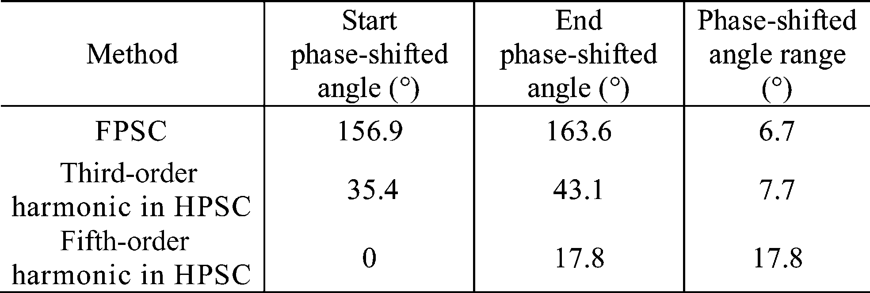

Efficiency Comparison

In order to verify the improvement of system efficiency from HPSC to usual FPSC, experiments for FPSC, the third-order harmonic in HPSC, and fifth-order harmonic in HPSC at their power range have all been tested. Here, the input power of three phase ac power and load power are measured, and then efficiency of the whole system is calculated. Similarly with Gk ,the normalized value Gp of output power is expressed as (8.3).The base value Po max is the max value of output power at actual zero phase-shifted angle using FPSC.

G_{P} = P_{OUT} /P_{Omax} …..(8.3)

The efficiency increases more than 10%at the light-load condition. Analyses and experimental results shows that the proposed method can improve system efficiency remarkably compared with the traditional fundamental- based phase shift control. Furthermore, improved power regulation precision and reduced switching frequency have been achieved simultaneously.

.

Fig.8.3. System efficiency with different methods at light load.

Fig.8.3 shows the efficiency at light load with these three methods. It can be seen that 1) system efficiency increased with higher output power; 2) system efficiency using HPSC is higher than that of FPSC at the same output power; 3) efficiency of the fifth-order harmonic in FPSC is higher than that of the third order harmonic in HPSC; and 4) the suitable Gp for HPSC isabout less than 15% in fact.

Comparison Under The Same Output Power

To compare the proposed HPSC and the conventional FPSC under the same output power, the following experiment is implemented. The output power here is about 88 W and Gp is around 5%. Detailed experiment data are shown in Table 5. As can be seen from this table, the fifth-order harmonic in HPSC improves efficiency of system with 10.09% compared to FPSC. It can be inferred that higher efficiency improvement will be reached at lighter load.

Table.5 Experimental Data With Different Control Methods.

Table.6 Experimental Parameters.

8.2 SIMULATION PROGRAM

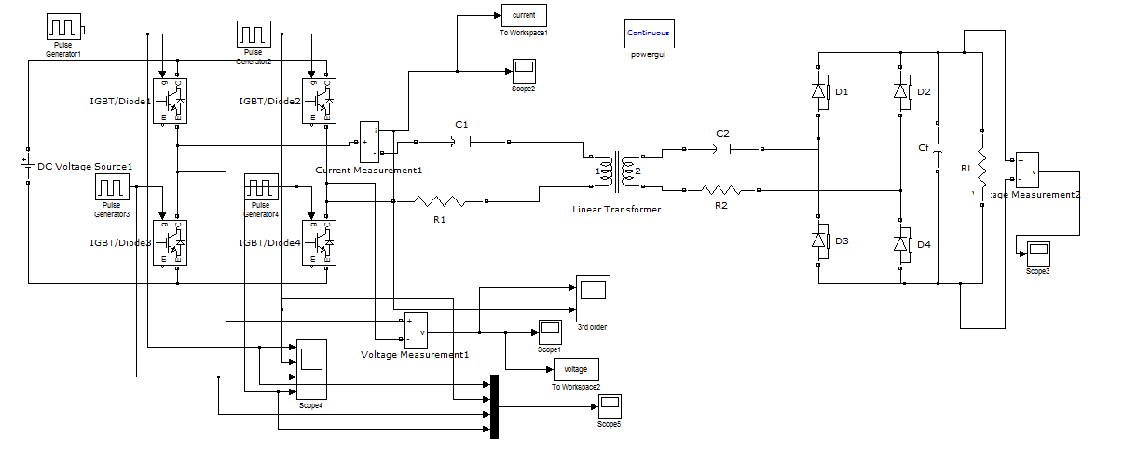

Fig 8.4. Simulation program for FPSC and HPSC

8.3 SIMULATION RESULTS

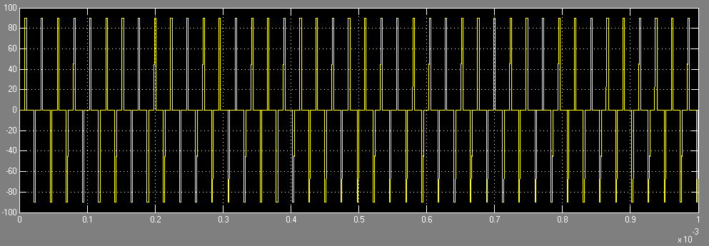

Inverter Output Voltage Waveform (U_{inv})

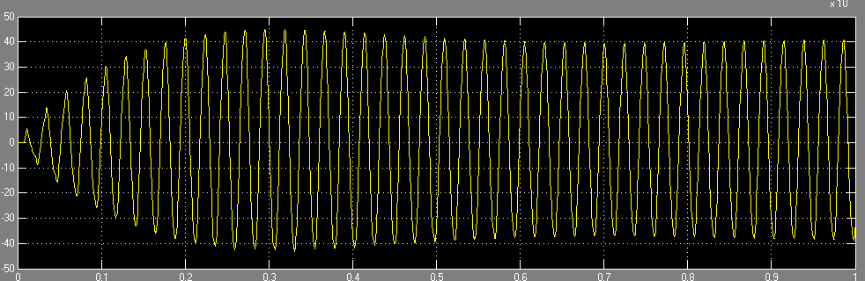

Inverter current waveform (I_{p})

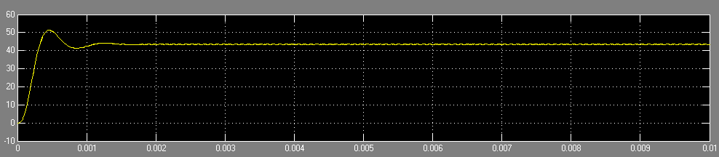

Voltage across load resistance (U_{RL})

- Output waveforms using FPSC

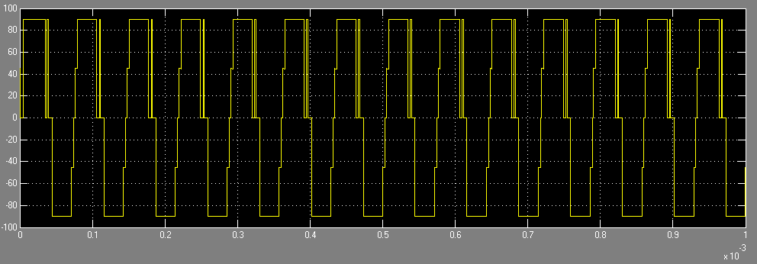

Voltage waveform of the inverter, 3rd order Harmonic in HPSC

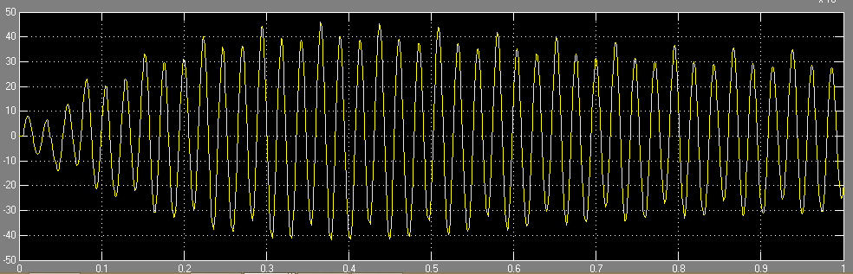

Current waveform of the inverter , 3rd order harmonic in HPSC

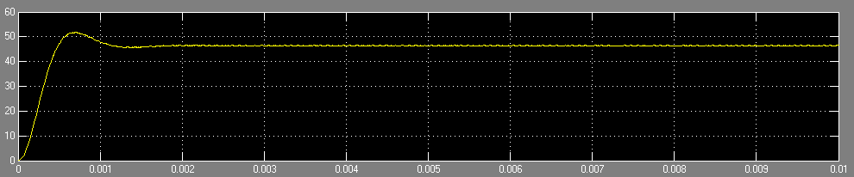

Voltage across the load resistance (U_{RL})

- Output waveforms using HPSC (3rd order)

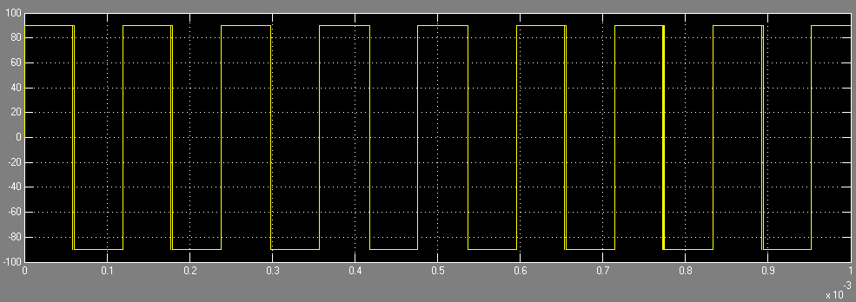

Voltage waveform (U_{inv})

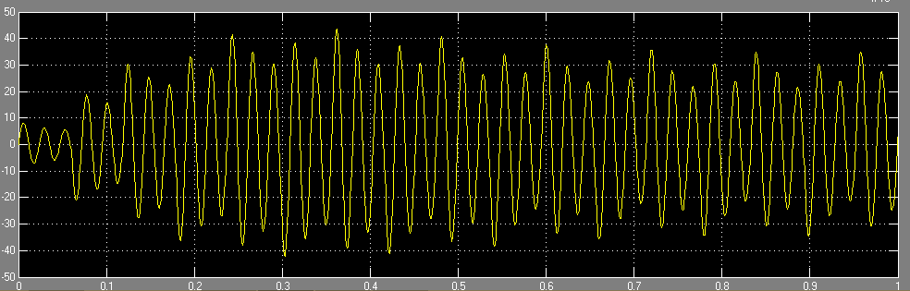

Current waveform (I_{p})

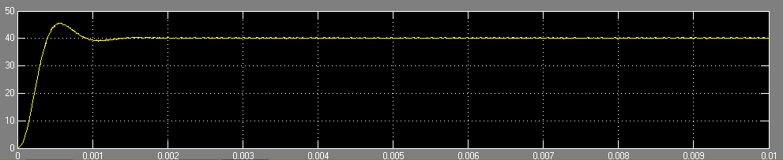

Voltage across load resistance (U_{RL})

- Output waveforms using HPSC, 5th order.

9. CONCLUSION AND FUTURE SCOPE

9.1 CONCLUSION

In this project, a novel harmonic based phase-shifted control method is proposed. With this method, the harmonic component other than the fundamental component of the resonant inverter output voltage is employed to regulate the transferred power. The output power is controlled by changing the phase-shifted angle of the inverter. Different from the conventional approaches, the switching frequency in this method is much lower than the resonant frequency, meaning much reduced switching losses. The operation principle, switching strategy, and dead-time effect have all been presented.

Analyses and experimental results shows that the proposed method can improve system efficiency remarkably compared with the traditional fundamental- based
phase shift control. Furthermore, improved power regulation precision and reduced switching frequency have been achieved simultaneously. Results of the investigation demonstrate that the proposed control method for the resonant converter can effectively improve the converter performance at the light-load condition. The efficiency increases more than 10% at the light-load condition.

9.2 Future Scope
ICPT, in recent times, is emerging as one of the vastly researched topics because of sheer number of applications of this technology. This topic is also very dynamic in nature as more and more innovative solutions are emerging. With respect to this thesis, there are many issues that have not been addressed and need further investigation. To start with, the design of ICPT transformer, which is arguably the most important component of a ICPT system, is not touched upon in this thesis. In literature there do exists some studies comparing different geometries and construction of ICPT transformer but these studies do not conclusively address the question of which configuration/geometry is best suited for a given application.

Secondly, the control aspects of a ICPT system are very faintly touched upon. There are some control strategies that have been presented but these are only discussed theoretically and not practically implemented. Practical implementation of these strategies would be necessary to study these strategies in detail.

Thirdly, in the application aspect, very simple EV and battery models were presented and used for the simulation of energy usage. It is recommended that more complex models that can more accurately simulate the energy usage should be used for similar studies in future. Also,108 economic and feasibility aspects of on-road charging of EV have to be looked into in more detail. Lastly, a CPT system must comply with guidelines that have been laid down by International Commission on Non-Ionising Radiation Protection to limit human exposure to time varying EMF with the aim of preventing adverse health effects. Therefore, an in depth analysis of magnetic field around a CPT system must be performed to ascertain human safety especially in high power applications.

REFERENCES

[1] A. K. Swain, M. J. Neath, U. K. Madawala, and D. J. Thrimawithana, “A dynamic multivariable state-space model for bidirectional inductive power transfer systems,” IEEE Trans. Power Electron., vol. 27, no. 11, pp. 4772–4780, Nov. 2012.
[2] H.Matsumoto, Y. Neba, K. Ishizaka, and R. Itoh, “Model for a three-phase contactless power transfer system,” IEEE Trans. Power Electron., vol. 26, no. 9, pp. 2676–2687, Sep. 2011.
[3] Y. Ota, T. Takura, F. Sato, H.Matsuki, T. Sato, and T. Nonaka, “Impedance matching method about multiple contactless power feeding system for portable electronic devices,” IEEE Trans.Magn., vol. 47, no. 10, p. 4235— 4237, Oct. 2011.
[4] S. Hasanzadeh, S. Vaez-Zadeh, and A.H. Isfahani, “Optimization of a contactless power transfer system for electric vehicles,” IEEE Trans. Veh. Technol., vol. 61, no. 8, pp. 3566–3573, Oct. 2012.
[5] G. A. J. Elliot, S. Raabe, G. A. Covic, and J. T. Boys, “Multiphase pickups for large lateral tolerance contactless power-transfer systems,” IEEE Trans. Ind. Electron., vol. 57, no. 5, pp. 1590–1598, May 2010.
[6] J. Kuipers, H. Bruning, S. Bakker, and H. Rijnaarts, “Near field resonant inductive coupling to power electronic devices dispersed in water,” Sens. Actuators A: Phys., vol. 178, pp. 217–222, May 2012.
[7] S. Raabe and G. A. Covic, “Practical design considerations for contactless power transfer quadrature pick-ups,” IEEE Trans. Ind. Electron., vol. 60, no. 1, pp. 400–409, Jan. 2013.
[8] K. W. Klontz, D. M. Divan, D. W. Novotny, and R. D. Lorenz, “Contactless
power delivery system for mining applications,” IEEE Trans. Ind. Appl., vol. 31, no. 1, pp. 27–35, Jan./Feb. 1995.
[9] D. J. Hartland, “Electric contact systems – Passing power to the trains,” in Proc. 5th IET Prof. Develop. Course REIS, London, U.K., 2011, pp. 60– 68.
[10] J. Huh, S. W. Lee,W. Y. Lee, G. H. Cho, and C. T. Rim, “Narrow-width inductive
power transfer system for online electrical vehicles,” IEEE Trans. Power Electron., vol. 26, no. 12, pp. 3666–3679, Dec. 2011.
[11] G. A. Covic, J. T. Boys, M. L. G. Kissin, and H. G. Lu, “A three-phase inductive power transfer system for roadway-powered vehicles,” IEEE Trans. Ind. Electron., vol. 54, no. 6, pp. 3370–3378, Dec. 2007.
[12] M. Bauer, P. Becker, and Q. Zheng, “Inductive power supply (IPSR_ ) for the transrapid,” presented at the Magn. Levitated Syst. Linear Drives, Dresden, Germany, 2006.
[13] (Jun. 2012). [Online]. Available: http://www.railwaygazette.com/news/ urban-rail/si-ngle-view/view/primove-induction-powered-tram-trialproves- a-success.html
[14] H. H. Wu, G. A. Covic, J. T. Boys, and D. J. Robertson, “A series-tuned inductive-power-transfer pickup with a controllable AC-voltage output,” IEEE Trans. Power Electron., vol. 26, no. 1, pp. 98–109, Jan. 2011.
[15] G. B. Koo, G. W. Moon, and M. J. Youn, “Analysis and design of phase shift full bridge converter with series-connected two transformers,” IEEE Trans. Power Electron., vol. 19, no. 2, pp. 411–419, Mar. 2004.
[16] H. L. Li, A. P. Hu, and G. A. Covic, “FPGA controlled high frequency resonant converter for contactless power transfer,” in Proc. IEEE Power Electron. Spec. Conf. 2008, Rhodes, Greece, 2008, pp. 3642–3647.
[17] C. S. Tang, Y. Sun, Y. G. Su, S. K. Nguang, and A. P. Hu, “Determining multiple steady-state ZCS operating points of a switch-mode contactless power transfer system,” IEEE Trans. Power Electron., vol. 24, no. 2, pp. 416–425, Feb. 2009.
[18] W. P. Choi, W. C. Ho, X. Liu, and S. Y. R. Hui, “Comparative study on power conversion methods for wireless battery charging platform,” in Proc. EPEPower Electron. Motion Control Conf., Ohrid, Republic of Macedonia, 2010, pp. S15-9–S15-16.
[19] J. L. Villa, J. Sallan,A. Llombart, and J.F. Sanz, “Design of a high frequency inductively coupled power transfer system for electric vehicle battery charge,” Appl. Energy, vol. 86, no. 3, pp. 355–363, Mar. 2009.
[20] C. S. Wang, G. A. Covic, and O. H. Stielau, “Power transfer capability and bifurcation phenomena of loosely coupled inductive power transfer systems,” IEEE Trans. Ind. Electron., vol. 51, no. 1, pp. 148–157, Feb. 2004.

